Exam: EDRS 810 ¹
Please post digital version on BB and turn in hard copies of exams by 4.30 pm on 4/30/12

- What is the difference between qualitative and quantitative research? Include mention of possible differences in purpose, method, data sources, data analysis.
The steps in the research are:
1- Identifying the problem – quantitative describes trends and explains the problem but qualitative explores a central phenomenon.
2- reviewing the research – both the quantitative and the qualitative research use research to justify the problem; however only in quantitative does the lit review plays a major role.
3- Specifying a purpose –In quantitative the purpose is specific and narrow and is measurable/observable; while in the qualitative studies the purpose is general and broad and the data is participants’ experience.
4- Collecting data –quantitative studies have numeric data, large numbers, and pre-determined protocols; while the qualitative studies use emerging protocols, text or image data and small numbers.
5- Analyzing and interpreting data –In quantitative data analysis a researcher will use statistics, describe trends and make comparisons between variables to support or discredit the original hypothesis; while qualitative analysis looks at processes/developing themes in order to develop meanings of findings.
6- Reporting and Evaluating –Quantitative research has a fixed standard and is objective and unbiased; while qualitative research tends to be more flexible as themes emerge. Qualitative research is reflexive and biased.
- Write the essential elements required in a Method Section for an intervention research study.
The essential elements required for a methods section of an intervention (experimental design/group comparison) are: Participants and their assignment, the materials, the design, data sources and the procedures (intervention and materials, control over extraneous variables and dependent measures or observations, collection of data). Very important is the fidelity of treatment…proof that the study is reliable
- Examine the following quantitative research question: “Do third grade students who participate in a supplemental English language program learn more language content as demonstrated on the Virginia SOLs than those who do not receive this supplementary English program?”

What is the independent variable? supplemental English language program

What is the dependent variable? Language content per SOL outcome

- List and describe each step in the Human Subjects review process at GMU (include all items from the GMU protocol in your response).
- Complete mandatory Human Subject training online
- Proposal
- HSRB application: The principal investigator (PI) prepares protocol for review which contains: 1) cover sheet 2) an abstract containing answers to all questions 3) answers to all protocol questions 4) parent consent form 5) student assent form 6) teacher consent form (if teacher is implementing research) 7) gatekeepter consent forms for site of study **materials will be attached for –all data collection tools with explanations.. The protocol is sent to Office of Research Subject protections (ORSP) for processing. Protocol is reviewed and nay needed additional information or clarification is obtained from investigators.

- Use SPSS to answer the following: Consider the intellectual functioning scores for the dogs below. For this set of scores:
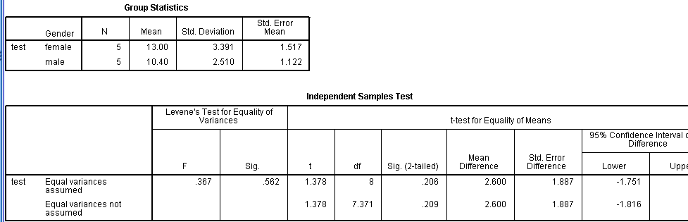
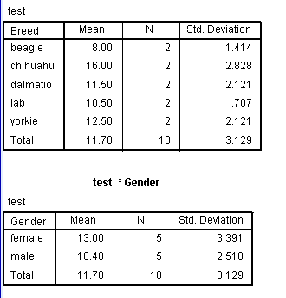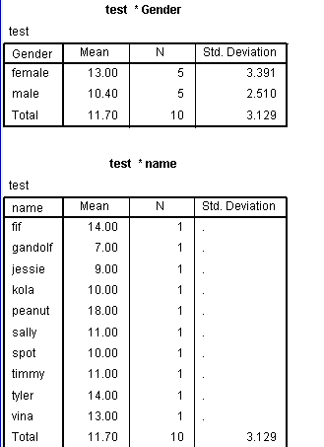
  - Compute mean scores, standard deviation scores, and frequency scores. Highlight the mean and standard deviation. (You may copy and paste your work into a word document).
  - Which dog performed the highest? Peanut, Chihuahua
  - Rank order the breeds from performing to lowest performing. Chihuahua, yorkie, dalmation, lab, beagle
  - List the means and standard deviations for males and females. Are these differences statistically meaningful?
  - Female Mean: 13.0
  - Male Mean: 10.40
  - Std. Deviation: .206 (assume equal variance) P value is higher than the significance level of 5% (.05) therefore there is ‘ NO STATISTICAL SIGNIFICANCE’ but a two-tailed test of significance is more demanding, rejecting the null hypothesis at either end of the curve.
  - Name Test Breed Gender
  - Kola 10 Lab M
  - Fifi 14 Yorkie F
  - Vina 13 Dalmation F
  - Tyler 14 Chihuahua M
  - Peanut 18 Chihuahua F
  - Timmy 11 Yorkie M
  - Sally 11 Lab F
  - Spot 10 Dalmation M
  - Jessie 9 Beagle F
  - Gandolf 7 Beagle M

- Design a ten item survey and include some basic demographic data items using the GMU web based survey software program. (http://websurvey.gmu.edu) Include a printout of your survey and a narrative description of procedures for optimal item construction in survey research and for obtaining a high response rate. Discuss how the procedures might vary across web-based and surface mail survey administrations.

(See last page for survey)

Optimal item construction necessitates the researche to have a well develop research questions in order to ensure survey questions use clear language, answer options do not overlap, shows respect for participant, and ensures questions are applicable to all participants. (1ocation 10673 kindle).

Obtaining a high response rate entails selecting as large a sample as possible so that the sample will exhibit similar characteristics to the target population and ensure a sufficient number of surveys will be returned. Researchers can pre-notify participants and provide incentives for those who complete the survey. Follow-up procedures include a second survey to be sent two weeks after the original, followed by a postcard reminder two weeks later.

Using web-based surveys enables extensive data to be gathered quickly and the researcher can employ tested forms and sample questions. However, email and web-based surveys have a low response rate and are not based on random sampling. Although, Mailed surveys too have low response rates (educational journals report a response rate of 50%. (location 10794 kindle book) following the following steps will improve the chances of high response rate: 1) construct clear and unambiguous questions, 2) pre-notify respondents, 3) adequate follow-up (mail survey, follow-up in 2 weeks with 2nd survey, send postcard after another two weeks), 4) use incentives.

- List software available to assist with data analyses for both quantitative and qualitative research. Indicate your comfort level with the software. How can you improve your comfort level with the various software?

Minitab 16 –unfamiliar

JMP –unfamiliar

SYSTAT –unfamiliar

SAS –fairly comfortable

MAXQDA –unfamiliar

NVivo –trained, familiar

SPSS –comfortable

In order to improve my comfort level with this (or any software) is to explore the programs, play with them, seek training videos, practice using the different functions and attempt to understand how it is used, why it is useful and learn functions.

- Discuss the process of data analysis in qualitative research, including exploring the data, developing themes from the data, coding data, and connecting themes. Describe also the role of the constant comparative method and triangulation of data.
Collecting data (stories, interview transcripts or notes) and analyzing the information can be a simultaneous process in qualitative research; the cycling back and forth between collection and analysis of the data is known as an iterative process. At times the report writing is done at the same time as well. Analyzing the data means a researchers reads it over many times to develop a deeper understanding and is better able to interpret the information. In order to analyze the data, however, it must first be collected then organized.

Collecting data means collecting text or words through interviews or field notes. These words must be converted into documents for analysis by organizing them inside a document to better identify and locate pertinent information. It is important to transcribe all words and ‘happenings’ during the interview/observation (i.e., “pause” for long breaks). Analyzing the data means coding it to mark parts of the text that share a common idea (i.e., teaching arrangement, seating, in vivo, lean coding) in order to form descriptions and broad themes that narrow the data into five-to-seven themes. Themes can be interrelated, interconnected or layered to form broad perspectives. One way to present findings is to compare groups by themes using comparison tables that show differences between groups. Another way to report the results of a research is to use triangulation to corroborate evidence from different data types. If using a computer program for analyzing. The program used will provide convenient features to facilitate data analysis. Computer programs will store, organize and label/code data for easy interpretation.

SRL
Please specify your race
American Indian or Alaska Native
Asian
Black or African American
White
I have the ability to complete all my homework each night.
never
sometimes
usually
always
I plan time each night for completing homework.
never
sometimes
usually
always
I am able to accomplish goals I set for myself.
never
sometimes
usually
always
I can stick to a plan that's working well.
never
sometimes
usually
always
I usually think before I act.
never
sometimes
usually
always
I call on others for help when I need it.
never
sometimes
usually
always
I keep track of my progress toward my goals.
never
sometimes
usually
always
My parent speaks English.
never
sometimes
usually
always
I have trouble making plans to reach my goals.
never
sometimes
usually
always

