*Determine if perceived teacher competence is a mediator between effort and overall amount learned.*

Hypotheses: Include a diagram of the proposed model.

**Effort (E) is expected to affect overall Amount Learned (OAL) through its effect on Perceived Teacher Competency (PTC).**

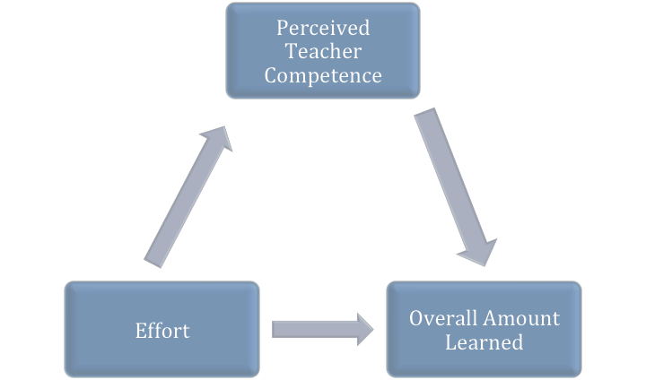

**(a) .400 (b) .644**

**(c) .159**

**Indirect Effect: a*b = .2576**

**Total effect = c + a*b = .4166**

Test of Assumptions

ID Case numbers were created to check for multivariate outliers.

**Univariate -** Computed scores to standardized zscore for each continuous variable to determine univariate outliers. The threshold for the three variables of Overall Amount Learned, Teacher Competency and Effort in our model are listed below (minimum and maximum). No outliers were detected. 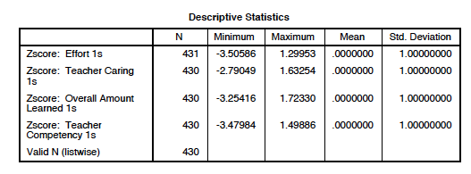

**Normality-**The assumption of normality was met. A histogram evidences a normal curve. Slight skewedness was observed but not enough to be of concern. Possible outlier detected (confirmation was made using the residual plot).

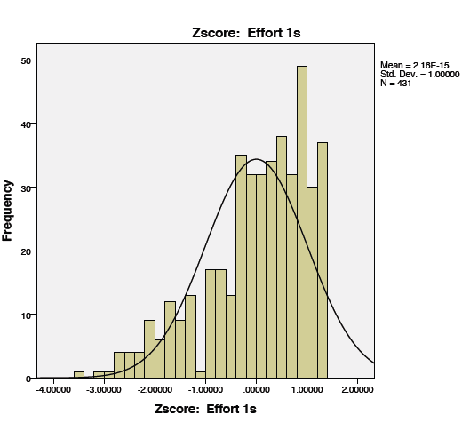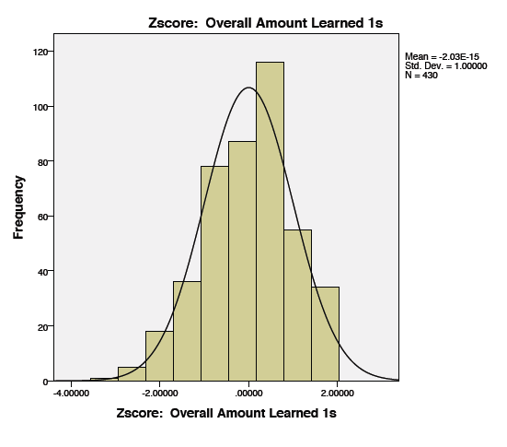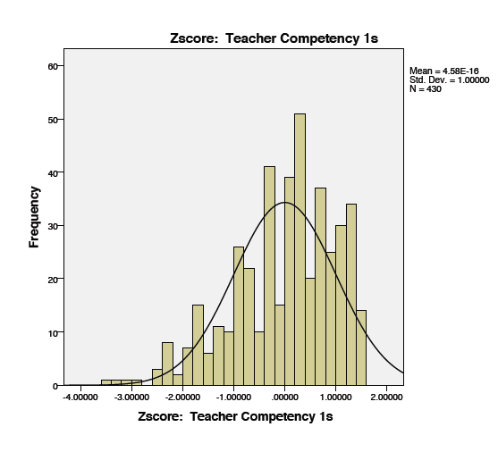

**Linearity**

The assumption for linearity was met. The residual scatter plot is rectangular with most of the plots in the center near zero.

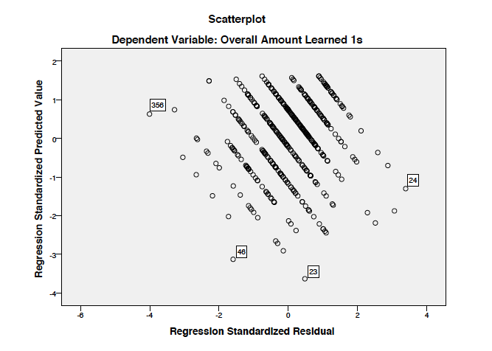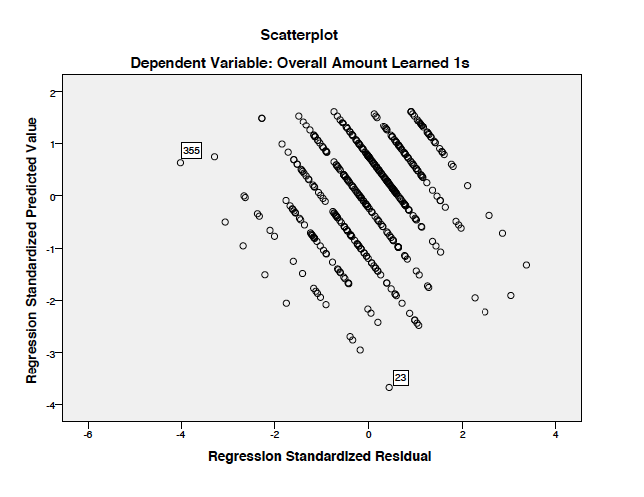

Mean 2.6151, N = 430 Mean 2.6212, N = 429

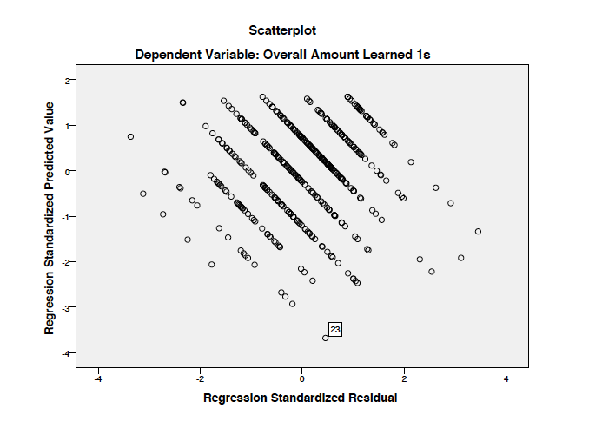

Mean 2.6262, N = 428

**Bivariate Outliers**

Assumptions of homoscedasticity was met. Using the residual plots, several outliers were detected according to the case ID numbers created to check for multivariate outliers, the case numbers included 17, 344, and 13. These scores were deleted sequentially as a visual check indicated they were potential outliers. Upon inspection of the data table it seemed possible that they were outliers due to possible data entry errors. For example, Case #17 showed ‘effort’ of 2.0 with ‘perceived teacher competency’ of .64 on ‘overall amount learned’ of 0 (zero). This combination of scores did not seem sensical, and therefore it was determined that the score was likely a data entry error. Data entry error was deemed also likely for case #344 that showed ‘effort’ at 3.71 with ‘teacher competency’ at 3.27 but an ‘overall amount of learning’ at .5. A residual plot was conducted after each deletion to examine how the change in MEAN changed the outliers still present. The last case deleted was #344 with a ‘teacher competency’ score of .36 and ‘effort’ of 1.43 on ‘overall amount learned’ of 1.

**Descriptive statistics:** Table of the correlations: strength of the relationship among all variables in the study. Conditions for testing for mediation are met.

All variables demonstrate a relationship: IV related to Mediator (.381); Mediator related to DV (.637); IV related to DV (.360).

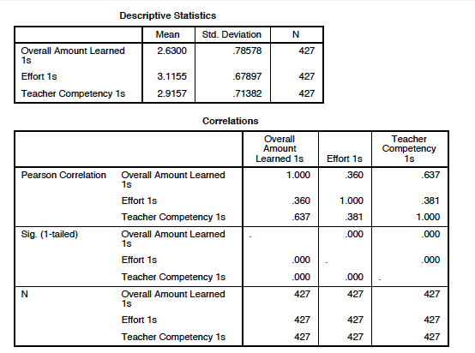

Hypothesis testing Baron & Kenny Assumptions for mediation.

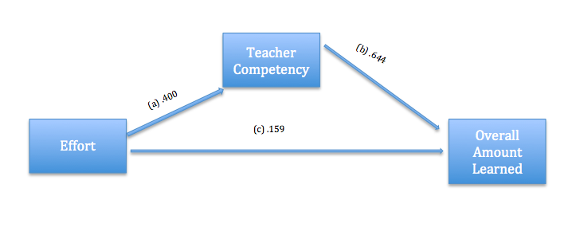

(1) Standard Regression for X1→ X2  a = .4

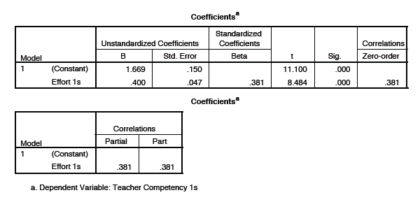

(2) Stepwise/Sequential Regression Model 1 for X1→ Yprovides the path coefficient for ‘a’ and the Sa  c = .159, Sa  = .046

(3) Stepwise/Sequential Regression Model 2 for X1, X2 → Y provides the path coefficient for ‘a’ and C b = .644, Sb = .044 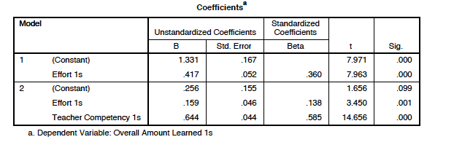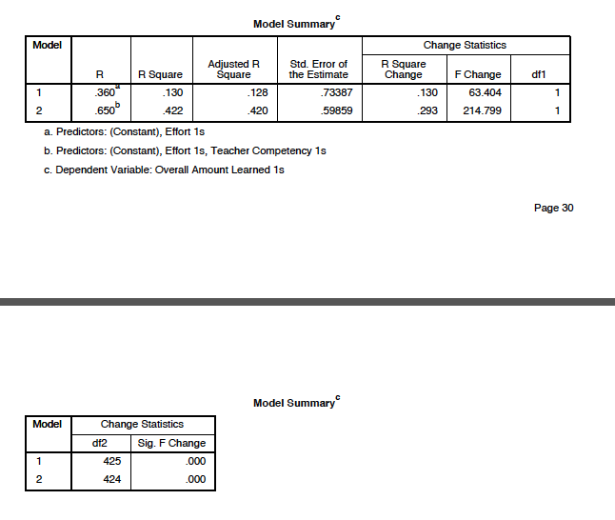

**Discussion:**  Include a brief discussion (3-5 sentences) of your results. Be sure to explain clear the mediational relationship.

The relationship between ‘effort’ and ‘overall amount learned’ is mediated by ‘teacher competency.’ The regression data shows that a partial mediation is occurring, all variables in our model are significant. The mediation is detected in the pattern change of effort (.417) from model 1 to the change in effort (.159) from model 2. This difference occurs because the mediator, Teacher Competency, explains why the relations exists between effort and overall amount learned (an additional 42% of the variance, as opposed to only 13% of the variance is explained when the mediator is included). A total effect of effort on overall amount learned is .427: “For each unit of increase in effort, we predict an increase in overall amount learned of .427.”

**Questions**

1. Explain any differences between the B&K approach and the PROCESS output. The B&K method does not test for statistical significance of the indirect effect of the mediation model. We don’t know if the significant difference is meaningful. However, the process method by Hayes uses a bootstrapping method (resampling method) to test for the statistical significance of the indirect effect using the 95% confidence interval.
2. What is the bootstrapped CI for the indirect effect? **Confidence Interval lower limit was .1976 and the upper limit was .3245** Is it significant? **Yes, the bootstrap CI is significant because the ab did not include zero.**
3. Conduct a Sobel test using your SPSS output—is it significant?

**The indirect effect is significant:** Z =7.357, p = .000

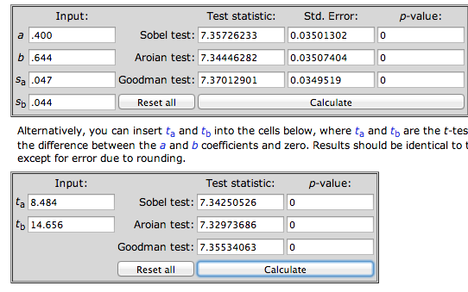

1. Add a second mediator (perceived teacher caring) to your model using PROCESS. Draw a picture of this model filling in path coefficients. Write 3-5 sentences explaining the model.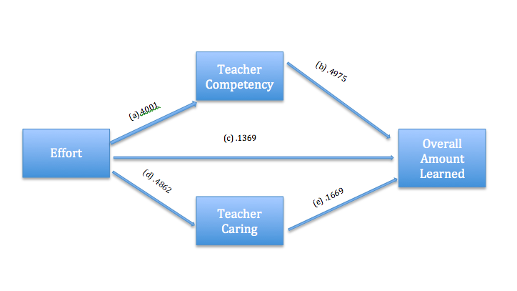

**Teacher Caring and Teacher competence are mediators between effort and overall amount learned. The total effect of effort on overall amount learned was .4170 and was found significant. The indirect effect was .2802 and was also significant. This was a partially mediated model of effort on overall amount learned because all paths were statistically significant. The indirect effect was .280. This was judged to be statistically significant, the CI lower limit was .2184 and the upper limit was .3498.**