Running Head: MOORE REPORT OF INTERNSHIP

Culminating Product EDUC 994: Written Report of Internship

Silvia Moore

George Mason University

**Analytical Section**

The internship teaching position with the College of Education and Human Development in the Early Childhood Education has bolstered my program rationale to ‘acquire a better understanding of the principles of learning, cognition, and motivation” by extending my current professional experience as a K-12 teacher with my course work in research methods and educational psychology. In some respects the work did not differ too much from the previous experience in the high school setting. College students, like high school students, remain in need of basic self-regulation skills as well as effective and interactive lesson plans and, a strong relationship with the instructor.

The opportunity to teach at university setting has piqued my interest for pursuing teaching positions at this level. However, one concern I have is my ability to demonstrate to a research university research experience that I have yet to acquire.

**Experience of Internship to Prior Experience and Learning**

In comparing the teaching experiences between the university and high school settings, I realize that the developmental differences were not as pronounced as I expected. Both groups seemed to necessitate a close and communicative relationship with the teacher as research tends to show, relatedness influences motivation (Appleton, Christenson, & Furlong, 2008; Fredricks, Blumenfeld, Paris, 2004; Pajares, 1996)); both sets of students had a small percentage that were in need of self-regulation (Bouffard-Bouchard Parent, & Larivée, 1991; Zimmerman & Labuhn, 2012) ; and finally, both the university and high school students thrived when feedback was formative and immediate (Gregory et al. 2011).

The differences between the university and high school students focused on the level of engagement in the classroom. University students, while less vocal, they were more prone to have deeper more meaningful discussions about subjects under discussion. Their lived experiences contributed greatly to my development of future lessons as I moved away from the textbook and sought ‘real’ examples from their world to provoke philosophical and Psychological discussions regarding the cognitive, social, and emotional development theories/perspectives.

**Outcomes of Internship to Prior Experience and Learning**

As the term concludes and I reflect on the skills my university students seem to be lacking, I have come to the conclusion that I misjudged their academic achievement motivation capacity. More than half of them did not read the assigned chapters for the course. One-third consistently submitted late work and missed 2 or more classes. My conclusion is that they are still kids!

The next time I teach this class (this summer), I will be cognizant that age is just a number. Young adults 18 to 22 are still developing their prefrontal cortex and with it their executive functioning ability (Berk 2013; Gregory, Beck, & Carr, 2011). I made many errors in the grading policy and in allowing students to submit work late without penalty the first time. This set a negative precedence. I can’t believe how many ‘sad’ stories were sent to me via email to explain why they missed a deadline! I certainly have to work on building a class structure that is developmentally appropriate for this age, while ensuring that I am guiding them to be their very ‘best’ selves. In retrospect, I should have shared with them the values of the classroom: communication, perseverance, timeliness, and seeking help.

**Evaluative Section**

Overall, I believe I performed my duties satisfactorily as I was offered another opportunity to teach this class again without supervision.

**Appraisal of Internship Learning Experience to Doctoral Goals/Level of Study**

The internship provided an opportunity to cement the theories of development replete in the educational research literature. In addition it allowed me the opportunity to put into place the classroom variables known to promote student self-regulation and engagement.

My classroom was created to allow students to ask questions and share ideas in a non-judgmental, enquiry based environment. I promoted this setting by ensuring that all student responses were validated. Responses were used to jump-start a conversation or to lead the class to explore possible answers. Furthermore, I communicated consistently with students and encouraged those that showed difficulty to seek help. Lastly, I encouraged students to think of me as their advocate, and someone who was available to help them succeed. The use of critical feedback framed with supportive notes resulted in the emotional well-being of my students and engagement with the curriculum (feedback received from students).

Teaching EDUC 302 I learned that Freshman and Sophomore college students have many things still in common with senior high school students. I set five learning goals for this internship:

1. Discuss the key theories in developmental stages of human development.
2. Examine and explain the contributions of heredity, environment, and child rearing practices to the total development of the child.
3. Understand the development, and/or, the application of theories as they apply to the instruction of children and adults.
4. Explain how people learn through active exploration and multiple interactions with materials other people, and the adults or leaders in their environment.
5. Demonstrate knowledge of contemporary theories of human development and their relevance to educational practices in early childhood, middle and adolescent education.

Several themes emerged in my journal entries as I worked through these goals. One, the importance of immediate feedback was paramount for student success, as well as for my own teaching practices. I endeavored to return papers quickly so that students had a chance to resubmit. In addition, I solicited feedback about my teaching practices and this helped to inform my teaching and allowed me to make appropriate changes to improve class engagement. Another theme that emerged in in my journal was the difficulty in keeping students engaged. It’s not enough to prepare good lessons, I also had to make it relevant and rewarding. When I assigned work that was not graded, the response rate was very low. However, when this was addressed by assigning a point system for completion, the submission rate increased but the quality was low. Students did not seem to self-regulate or engage with the material at a high level until the work was linked to a final product at the end of the semester. The internship successfully allowed me to experience manipulating the environment to affect a change in student levels of self-regulation and engagement.

**References**

Appleton, J., Christenson, S., & Furlong, M. (2008). Student engagement with school: Critical conceptual and methodological issues of the construct*. Psychology in the School*, 45(5). DOI: 10.1002.pits20303.

Berk,

Bouffard-Bouchard, T., Parent, S., & Larivée, S. (1999). Influence of self-efficacy on self-regulation and performance among junior and senior high-school age students. *International journal of Behavioral Development*, 14(2), 153-164. DOI: 10.1177/016502549101400203.

Fredricks, J., Blumenfeld, P., & Paris, A. (2204). School engagement: Potential of the concept, state of the evidence. *Review of Educational Research,*74(1), 59-109. DOI: 10.3102/00346543074001059

Gregory, J. B., Beck, J. W., & Carr, A. E. (2011). Goals, feedback, and selfregulation: Control theory as a natural framework for executive coaching. Consulting Psychology Journal: Practice and Research, 63(1), 2638. doi:10.1037/a0023398.

Pajaras, F. (1996). Self-efficacy beliefs in academic settings. *Review of Educational Research,* 66(4), 543-578. DOI: 10.3102/00346543066004543.

Zimmerman, B. & Labuhn, A. (2012). Self-regulation of learning: Process approaches to personal development. *Educational Psychology Handbook*, 1, 399-425. DOI: 10.1037/132273-014.

**Appendix**

**EDUC 994: EDUC 302 Journal**

January 22, 2014

In preparing to teach EDUC 302, I  had focused too much on the content and did not give enough attention to the administrative task involved in preparing to deliver the course.  The syllabus I submitted was sent back to me for revisions twice! Then, I requested to revise it a third time to include revisions discussed with Dr. DeMulder (internship supervisor). I’m afraid I may have given a bad impression to the office and hope to dispel any misgivings by ensuring students in my course learn and enjoy the class.

My biggest fear in teaching this course has been that I won’t have the answer when asked to clarify a topic. I think this is why I’ve dedicated an inordinate amount of time to reading and rereading the material to the detriment of the preplanning. I believe, I have conquered this fear.  After meeting with Dr. DeMulder I decided to changed a few things in planning for the course. First, I revised the syllabus to clarify assignments and due dates; next, I created course agenda for myself with timelines, resources and talking points. And, finally, I planned end-of-class discussion/journal entry focussed on the night’s topics.

I’m looking forward to teaching EDUC 302 focused on the domains: physical, cognitive, and emotional/social. I had planned to use the first two weeks to introduce students to the topic of lifespan with an overview of terms and domain definitions; while the third week would have been dedicated to the prenatal to birth stage. However, because of the snow day, I have decided to fold day 3 into the day 4 schedule. Meaning, I will cover prenatal to newborn (all aspects) and Infant to early childhood (physical development). I believe this will be an easier recovery of the 3 hours lost, as  I think a strong foundation for the class structure, topics to be covered, and terms will be important for students success, thus the first two classes are crucial and will remain as planned. I’m anxious to begin!

**January 29, 2014**

I taught the class for the first time last night. I arrived 30 minutes earlier (thank you for the advice Dr. DeMulder) to discover that the room had no built-in projector. I called the number on the wall (tech) and then went down to room A108 to pick up a projector. I was able to set up before the class. I was nervous enough without this hiccup, but because I was not rushed it did not create undo stress.

I used the first 1 ½ hours of the class for introductions.  I used the tent name activity for quick introductions. Students introduced themselves and explained the drawings that represented something about themselves. This was a good ice breaker. I followed this activity with a request for students to build an ecological system which they should have read about in chapter 1. I first displayed my ecological system (below) and explained how each of the systems outside my micro influenced me.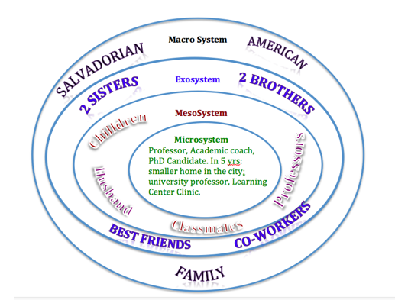

This activity worked out better than I had expected. At first students were hesitant to share but then one or two in the group began. I walked around the room and made comments or answered questions during the discussion. After the group discussion one student from each group reported the similarities and differences that made up their group.

The second half of the class was a combination of lecture/questioning and syllabus clarification. During the lecture/questioning portion I introduced terms and concepts from chapter 1. I tried to get students involved by asking questions like , “how do we get along?” “what are the skills needed to get along well with others?” “What are some common emotions?” “How do we learn to manage them?” “What are other types of personalities?” “How is it possible that siblings in the same household can have different temperaments?”  Only ¼ of the students responded, I found myself telling more personal stories to get them to laugh or be more engaged. I definitely MUST weave in more discussion groups.  Next week the librarian will give a short presentation on how to use library resources. I will follow this visit with a group literature review activity. Each group will be given a short article about how biological and environmental factors influence learning. Students will read, fill in a critique/review sheet, then report back to the class. This should take 30 minutes!

Overall I think the class went well. They were tired by 9:30 and some were drifting off. I saved the syllabus till last as I thought that would keep them awake for the last 20 minutes! This week, I will search out five (5) short articles for class activity and will use reflection journal for last 20 minutes of class.  I think I need one more class period to gauge the timing of class lectures, group discussions, and group work.

**February 5, 2015**

Last night’s class was an epiphany...The class began with a tutorial by Anne Driscoll, the librarian. She demonstrated article searches and answered questions. I used this introduction to lead the class through the mechanics of writing a article critique with an article on “how poverty affects executive functions of students.”  I had planned for students to read the article independently then  answer prompts in small groups followed by a ‘report back’ to the class. However, it became clear from questions they asked as they were reading that group discussions were not going to work. Too many of them were reluctant to speak out. Instead, I decided to hold a ‘whole’ class discussion. We dissected the article using the article critique rubric. By 8:30, most students were participating in an animated discussion about how important it was for teachers to be acquainted with theories of development. From this episode, I realized that this group is going to need more activities than I had initially planned.

While the discussions flowed into the class topic for the night, theories and genetics/environmental foundations it was clear that I need to bring the text to life if I’m going to keep my class awake. Many students volunteered that they had initially not been motivated to read the article critically, but changed their minds once we began the ‘whole’ class article critique/review. Some students shared that they had not been aware of how important it was to look at student behaviors not as ‘bad’ or ‘good’ but with an understanding that behaviors are indications of where they are in the continuum of development, and the importance of meeting students ‘where they are.’

The rest of the night was spent viewing a video on genetics and discussing textbook concepts/vocabulary in the context of the research article, video, and life in the classroom. I really enjoyed the interaction, but worry about  a group of 10 students in the back that are not participating in the discussion. Next week, I plan to start the class with an article review exercise which I will use to mix the students in the back of the classroom into new groups with more vocal students. I imagine I will have to try different tactics until I find one that works to get more participation.

The first group presentation is next week. Students asked a lot of questions about the expectation (they did not read the syllabus!) but I think that they left last night’s class feeling ready. I heard others say that they were going to learn from the first group.  The online quiz feedback was positive. Most students realize that the quiz is a quick reading check up and that the scores reflect reading comprehension.

I will canvass the class in a couple of weeks to get their opinion on how the class is going and what I can do to improve their classroom experience.

**February 11, 2014**

This week I was crazy! Because of the snow day, I decided to show a film on conception to birth and only focus on the capacities of newborns to socialize and the four stages of arousal. I think the students appreciated this as most of them are years from having babies (I hope?)  I did however, include genetic material in the online quiz from chapter 3. I warned them that I would and they seemed okay with this. I spent a lot of time developing their background knowledge of the physical domain. We watched two short films on the Brain and motor development. The focus of the class was on brain development and the experience-expectant and experience-dependent brain growth as well as factors that impacted learning.

The first group presented a summary of chapters 1 and 2 and did a relatively good job. I was impressed with their warm-up exercise: answer on a piece of paper as question posed by a student, “Mrs. ?, where do babies come from.”  This was a great ice breaker.  A lot of students who normally do not talk were animated in their opinion sharing.  Some of the students were very nervous and came to me later in the night to share with me how intimidated they were to present.  I think it was a good exercise in lesson planning and presenting and will use it again next time I teach the course.

I’ve spent most of my time this week grading the article critiques. I’m surprised how many students were late with the paper. It is Friday today, and I still have one student who has not submitted it. I hope I have graded fairly. It is so hard to grade papers that are not written well. I’m so tempted to deduct for that! But, I didn’t. I stuck to the rubric.  Below is an example of one paper I graded. The student received 8/10 grade with a comment of “Some important points are left out. Terms or theories from the course are touched upon but not clearly used to evaluate the articles effectiveness.”

I let the class out 20 minutes early Tuesday with instructions to reflect on an article they read in class and discussed in groups. Only 3 students submitted a reflection! I sent an email asking them to please submit reflection as it was an opportunity for me to hear from some of them that do not speak out in class. We’ll see what happens.  Next week, my class meets in the acquatic center. A friend of mine who does Brain Gym will speak to the class and lead us in some exercises that represent the physical development of infants to toddlers, our class topic.

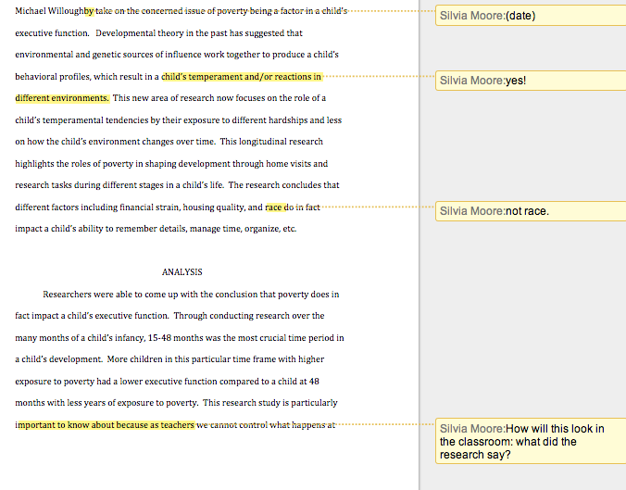

**February 23, 2014**

Last Tuesday we had a guest speaker. I thought I would add a little fun to the class by holding the class in the acquatic center to give the class enough space to put in practice what the speaker would be talking about. Brain gym and the stages of motor development of infants and how that impacts their later participation in sports and classroom writing tasks.  The presenter led us in exercise movements that simulated the movements necessary to go from one stage of development to the next. sitting up, movement from one side of the body to the other and how the upper body development preceded the lower body. How this is necessary for skipping and why skipping is a indicator of whether or not children learned body movement in the proper sequence of if they skipped a stage.  I think students appreciated the change and it was a good lead into the class topic of physical development from early toddlers to early childhood.

For the first time since beginning the course, I did not prepare as I should have and did not have an interactive lesson planned. I wanted to get through the topics and move into the field study clarifications. The lesson did not go well and by 9:15 I knew I had lost the group. several were in the back sleeping and trying hard to stay awake. I decided to wrap up and invite students to remain to get individualized help with anything they would like to discuss. I gave them an early-out assignment of completing a survey to assess how the class was progressing.

The survey revealed exactly what I had seen in Dr. DeMulder’s survey of her class last Spring.  Students like discussion in small group then reporting back to the class. More complained about the timing of the class. I will try to address this by doing more journal writing at the end of the class to give students the option of leaving and doing them from home.  Many enjoy the online quizzes because of the immediate feedback and the promise that the final will be a similar experience.  More than fifty-percent of the class has asked to do more article critiques to practice their writing. I’ve decided to do an article critique for the mid-term. Details are unfolding in my mind...will think through it better and write about it next week.

**February 26, 2014**

This was the last week of the physical domain. I chose to focus on the domains and stages of physical decline from early to late adulthood. Specifically, I focused on the impact of nutrition and stress on brain development. I think students found it relevant.

I tried to show a TedEx video but the sound system failed and the content was lost on the students without good sound. Too bad, it was the genome project research on telomeres. I followed  the video with an article on how mice are reacting to telomere injections (rejuvenated systems).  That got them talking about the implications of the right and wrong to reorder nature. I was able to get them back on track by discussing the impact of this research on the funds that the government would have available if they could use the 41% of the federal budget spent on the elderly  to bolster the 10% dedicated to children.  Well, that went in a direction I had not intended…”the government will not do the right thing!” I finally stopped the conversation with, “if you vote you can change this.”

After break, I was finally able to move on to the field experience ‘hands-on’ activity. Half the class has been assigned to a school. Homework last week was to do a background search of the school (greatschools.org) in order to add it to a design map to be submitted for a grade. Students came to class with their design maps and were paired with a student whose turn to submit a design will be next week.  The activity entailed the student with the design map to share that information with his/her partnered student.  The student partner’s job was to take notes and transform what they heard and the information in the design map into an abstract (a 2-minute elevator speech). After 20 minutes, the student tasked to write the abstract read it for the class. I made comments about the intended theories to be used, how else they could be applied, or just gave advice about how the demographics, size, location of the school could lead to other interesting questions. 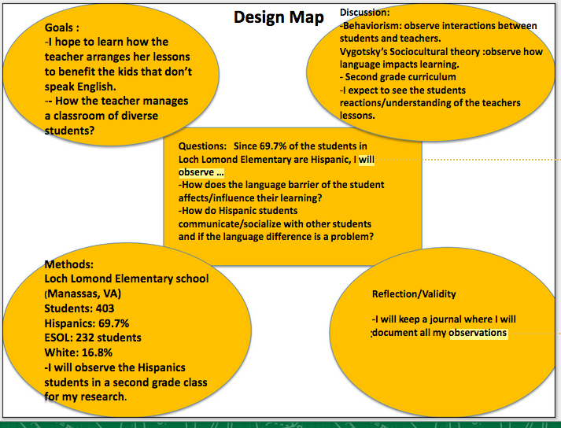

I really believe I hit gold last night with this exercise. We are doing it again next week with the other 15 students who had not been assigned to a school. In addition, we will have a 20 minute group-summary presentation on the physical domain. Then, I will introduce the cognitive domain and lead the class in a discussion of the Big-Five personality research which they will use to write a reflection in their online journals.

For the midterm, I have chosen to give them C H A P T E R 1 9, “HOW NEUROSCIENCE CONTRIBUTES TO OUR UNDERSTANDING OF LEARNING AND DEVELOPMENT IN TYPICALLY DEVELOPING AND SPECIAL-NEEDS STUDENTS” by James P. Byrnes in  the APA Educational Psychology Handbook: Vol. 1. Theories, Constructs, and Critical Issues, K. R. Harris, S. Graham, and T. Urdan. Students will have an opportunity to read and ask question about the chapter during the last 30 minutes of the class, if they choose to stay. I really didn’t want to do a midterm but I think this will be a good way to give them a foundation for the rest of the semester topics. (I hope?)

**March 6, 2014**

This past Tuesday was interesting: 5 students missed class, 2 students have not submitted their article critique, 4 students did not do the online quiz, and of those that did submit the quiz  averaged 68%!

The Blackboard quiz tool generates a report with an item analysis. I showed the students the types of questions most missed in the quiz (application of theories). I got a sense that most of them are taking the quiz but not thinking through the theories we are discussing. I’ve directed them to study page 22 of the textbook as a guide for the remainder of the semester, as both the book and I will focus on how the theories of learning apply to their future work in k-12 classrooms and human development understanding for teaching the ‘whole’ child.

I’m very surprised with the quality of the work that is submitted. Most of the students turn in unedited work or superficial work. I’ve returned work asking them to elaborate on the description of theories and how these theories apply to their own development. I’ve offered full points to those who resubmit with revisions.  This is more work than I had anticipated but I really want these students to understand the theories of learning and use them to look at the ‘whole’ child when they become teachers.

This week we met right up to 10pm. It was a jammed packed night: nuts & bolts, group presentation, discussion of the Big 5 and how personality  affects learning, design map pair-share and abstract creating, and finally...the topic of the night, cognition from infancy to early childhood with an emphasis on theories: Piaget (sensory), Vygotsky (language/expert), Chomsky (language & the information processing theory).  I really enjoyed teaching this section and the students  seemed more engaged than usual. They asked lots of questions and I used small groups every 30 minutes to discuss concepts. Overall, I think the class  went well because of the small group activities.  I’m feeling more efficacious with every meeting. Thorough prep is a MUST.

**April 7, 2014**

Last week the unit on cognitive domain was completed. I really enjoyed teaching this unit as it allowed the discussion of how teachers impact the learning and how cognition is influenced by the other domains.  Students were given several outside resources to read, articles and research papers to further explore how ability is unstable and how it is influenced by others and the environment.

The field experience report is a major grade of this class, and thus I chose to make a midpoint check the midterm. Students submitted the first two parts of the paper: abstract and a review of the literature.  On a scale of 12.5 (half the 25 points of the final paper), most papers fell in the 10 point range. For the most part, it seems students are beginning to understand how to apply the theories of learning to what they know about teaching.

I don’t think the students are reading the textbook. The online quizzes, which consist of questions generated from the book resources, evidence that most students are not reading as they are around the 64% mark.  I brought this to the attention of the class last week and reminded them that the final will be a compilation of theories they should understand and know. I think the next time I teach the course the online quizzes will make-up 10% of the class and will be weighted for the midterm.  Will this ensure they read the textbook?

Why is it important that they read the textbook? Because they are not participating in class at a meaningful level. I am spending a lot of time going over and over the theories of learning that they should be familiar with since chapter 1 of the textbook.

I have incorporated more videos and group work each night and this seems to help them stay awake. Tuesday, we begin the socio/emotional domains.

**April 11, 2014**

Okay...I learned a very important lesson Tuesday night. Student presentations are boring! Group 3 presented the cognitive domain review and it was a lot of information. Most of the students were not listening. I caught glimpses of a few reading books, texting, and/or surfing the net.  I found myself drifting away from the presentation until I started making questions for the final from their presentation. I stopped the presentation three times to share the questions I was generating from the presentation with the class. I told them that the information that was being presented was definitely going to be on the test and the questions that I was sharing with them would DEFINITELY be on the test. More started paying attention.

I will teach this class again this summer. Three things I will change: one, the online quizzes will count. Two, during group presentations student audience will be expected to generate questions for the final...the best question will be added to the test and the author will gain 3 extra credit points. And, the third thing I will change will be that I will use a 20-10-20 approach: 20 minute lecture-10 minute interaction/group work-20 video.  I did it this past week and it seemed to keep students more focused. Also, the videos presented must also generate questions for the final or they become irrelevant for the students. It seems most do not care about learning as much as they care about getting the grade and moving on.

Overall, I think that I’m doing a good job preparing them for a career in the classroom. I have taken the approach that every aspect of the class is a lesson in human development that will make them better teachers, as they will be better prepared to interact with all types of students, parents, and colleagues. I’m enjoying the stress that comes with trying to prepare lessons that are appropriate and transforming students to think about teaching lessons using the learning theories that address the ‘whole’ child.

**April 18, 2014**

Three more weeks! is that possible? The time has gone by so fast.  Student’s are starting to worry about their grades and asking me questions about how to improve the grade. I have been proactive in using blackboard to keep up with what is missing and updating their attendance to show them how missing class impacts their overall grade. Each class is worth 1 point of the overall 15 points of the class. It just so happens that we meet 15 times! I have had no ‘real’ complaints.

I’m starting to see anxiousness about the final. I have decided to do the final online using the short answer questions from the book and two scenarios that ask them to discuss what is going on in the scene from the perspective of each theory we have discussed. I will make some questions multiple choice as I do want them to ‘remember’ key concepts and theories. But for the most part, I want students to walk out of the class being able to understand the stages of development that they can expect in the classrooms they teach. And, more importantly, I want them to know how stages of developments can help them gauge interventions necessary for low/high performers in their classrooms.

This week we are focusing on emotion and social development. I’m so glad I left this to last as it brings all the other domains into the conversations. I think that they are truly seeing the multidirectional and multidimensionality of domains.

I have decided to limit presentations to one slide per student...this, I hope, will force them to focus only on what they think was important. I have decided that they do not have to come up with a group activity, as I have decided that the activity is that all students must submit at least three questions for the final exam from the presentations. I’m hoping that this will help them be more engaged during presentations instead of using the time to check emails or read their books.

April 21, 2014

Tonight was my last class. I did not realize that next week we could not meet because it was a snow day make-up. And, since I have decided to allow students to take an online final, we will not meet again. As the term concludes and I reflect on the skills my university students seem to be lacking, I have come to the conclusion that I misjudged their academic achievement motivation capacity.  More than half of them did not read the assigned chapters for the course. One-third consistently submitted late work and missed 2 or more classes.  My conclusion is that they are still kids!

        The next time I teach this class (this summer), I will be cognizant that age is just a number. Young adults 18 to 22 are still developing their prefrontal cortex and with it their executive functioning ability (Berk 2013; Gregory, Beck, & Carr, 2011).  I made many errors in the grading policy and in allowing students to submit work late without penalty the first time. This set a negative precedence.  I can’t believe how many ‘sad’ stories were sent to me via email to explain why they missed a deadline!  I certainly have to work on building a class structure that is developmentally appropriate for this age, while ensuring that I am guiding them to be their very ‘best’ selves. In retrospect, I should have shared with them the values of the classroom: communication, perseverance, timeliness, and seeking help