**Results**

|  |  |  |  |  |
| --- | --- | --- | --- | --- |
| Table 1 Descriptive statistics | | | | |
|  | N | Mean | Range | St.dev |
| Overall Amount Learned | 427 | 2.6300 | 1-4 | .78578 |
| Effort | 427 | 3.1155 | 1-4 | .67897 |
| Perceived Teacher Competency | 427 | 2.9157 | 1-4 | .71382 |

A multiple regression analysis was conducted to determine if perceived teacher competency mediated the relationship between effort and overall amount learned (Research Question 1); and, if perceived teacher caring with perceived teacher competency mediated the relationship between effort and overall amount learned (Research Question 2). The results of the analysis are presented in three sections: Research Questions 1, Research Question 2, and Research Questions 1 & 2. Sections 1 and 2 contain sub-sections titled ‘descriptive statistics and correlations’; ‘path analysis’; and ‘mediation analysis,’ which explain how the results were obtained and the interpretation of those results. The last section explains how the models examined compare to each other. The population size for the analysis was N = 427.

**Research Question 1**

**Descriptive Statistics and Correlation for RQ1**

A multiple regression analysis to assess if perceived teacher competence is a mediator between effort and overall amount learned was performed (Research Question 1). Preliminary examinations conducted with histograms and scatterplots indicated that scores on the dependent variables were linear and approximately distributed with seven (7) outliers. Because these outliers were thought to be extreme, the score were examined and deleted due to possible data entry errors. A residual plot verified the assumption of homoscedastic was met.

Correlation analysis (Table2) shows that overall amount learned was positively correlated with effort and perceived teacher competency, and teacher competency and effort were also positively correlated. Assumptions for mediation were met (see table 3).

|  |  |  |  |
| --- | --- | --- | --- |
| Table 2  Correlation between variables (* < .001) | | | |
|  | Overall amount learned | Effort | Perceived Teacher Competency |
| Overall amount learned | 1.000 |  |  |
| Effort | .360 | 1.000 |  |
| Perceived teacher competency | .637 | .381 | 1.000 |

**Path Analysis for RQ1**

A path analysis was produced in order to investigate the relationships between the variables. The model (figure 1) showed that effort had both a direct effect (C’ = .159) on overall amount learned and an indirect effect (a*b = .2576), via

Figure 1 unstandardized path coefficients

* p < .000, ** p < .05

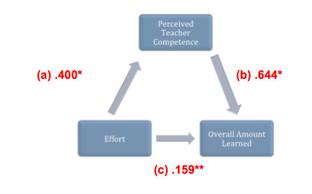

perceived teacher competence. The model accounted for 42% of the variance in overall amount leaned (total effect = .4166), and it showed very good fit to the data, R = .6499, R2 = .4224, F (2,424) = 146.446, p < .000. Table 3 shows the paths statistics.

|  |  |  |  |
| --- | --- | --- | --- |
| Table 3 Path statistics  * p < .000, ** p < .05 | | | |
| Model | Unstandardized | | t |
| B | Std. Error |
| Effort 🡪 TPC | .400 | .047 | 8.484* |
| Effort 🡪 OAL | .159 | .046 | 3.450** |
| PTC 🡪 OAL | .644 | .044 | 14.656 |

**Mediator Analysis for RQ1**

While the correlation and path analysis provided some support for establishing of mediator effects, these effects should be tested for significance. According to Baron and Kenny (1986), a mediator effect occurs when the relationship between the predictor variable and a dependent variable is affected by an intermediate variable. Therefore, it was possible to test the significance of the mediating effects (.2576) of the proposed mediating variable perceived teacher competence on the relationship between the predictor variable effort and the outcome variable overall amount learned (OAL) using the Sobel (1982) test (below).

* Effort 🡪 perceived teacher competency 🡪 overall amount learned (Z = 7.3573, p < .000)

Using the SPSS script for the indirect procedure (Preacher & Hayes, 2008), bootstrapping was performed; 427 samples were requested; a bias-corrected and accelerated confidence interval (CI) was created for *ab*. The indirect effect at the 95% CI with a lower limit of .1976 and the upper limit of 3245 was found to be statistically significant as the *ab* CI did not include zero.

The results of the analysis showed that effort predicts overall amount learned and perceived teacher competency predicts overall amount learned. In addition, this investigation indicates that teacher competency is a mediator between effort and overall amount learned; therefore it is reasonable to assume that effort exerts its primary influence on overall amount learned indirectly, via an effect on perceived teacher competency (.2576). As effort was more strongly related to perceived teacher competency, and not to overall amount learned, this theoretical assumption is further strengthen.

A comparison of the coefficient for the direct versus indirect paths ( C’ = .159 vs. ab = .6439) suggests that a large part of the effect of effort on OAL is mediated by PTC. In other words, perceived teacher competency is a strong mediating variable through which effort influences overall amount learned.

**Research Question 2**

|  |  |  |  |  |
| --- | --- | --- | --- | --- |
| Table 1  Descriptive statistics | |  |  |  |
|  | N | Mean | Range | St.dev |
| Overall Amount Learned | 427 | 2.6300 | 1-4 | .78578 |
| Effort | 427 | 3.1155 | 1-4 | .67897 |
| Perceived Teacher Competency | 427 | 2.9157 | 1-4 | .71382 |
| Perceived Teacher Caring | 427 | 2.5312 | 1-3 | .89774 |

**Descriptive Statistics and Correlation for RQ2**

A multiple regression analysis was conducted to assess if the predictive value of effort on overall amount learned was mediated by perceived teacher competency and perceived teacher caring (Research Question 2). Preliminary examinations conducted with histograms and scatterplots indicated that scores on the dependent variables were linear and approximately distributed with seven (7) outliers. Because these outliers were thought to be extreme, the scores were examined and deleted due to possible data entry errors. A residual plot verified the assumption of homoscedastic was met. The population size was N 427; table 4 shows the descriptive data for this analysis.

|  |  |  |  |  |
| --- | --- | --- | --- | --- |
| Table 5  Correlation between variables (* < .001) | | | | |
|  | Overall amount learned | Effort | Perceived Teacher Competency | Perceived Teacher Caring |
| Overall amount learned | 1.000 | ----- | ---- | ---- |
| Effort | .360 | 1.000 | ---- | ---- |
| Perceived teacher competency | .637 | .381 | 1.000 | ---- |
| Perceived Teacher Caring | .567 | .368 | .736 | 1.000 |

Correlation analysis (Table 5) shows that all variables in the model are correlated. Overall amount learned was positively correlated with effort (.360), perceived teacher competency (.637) and perceived teacher caring (.567). Effort was correlated with perceived teacher competency (.381) and perceived teacher

caring (.368); and finally, perceived teacher caring was correlated with perceived teacher competency (.736). Assumptions for mediation were met (see table 6).

**Path Analysis for RQ2**

Figure 2 unstandardized path coefficients

* p < .000, ** p < .05

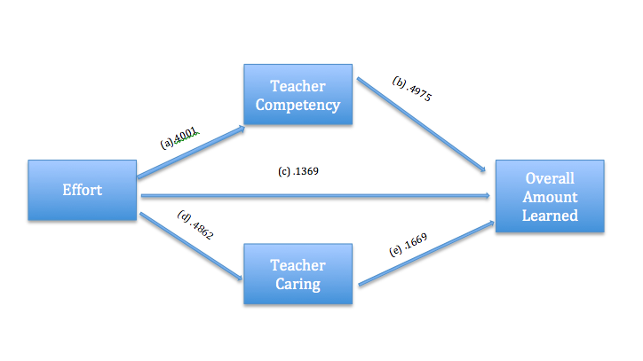

A path analysis was produced in order to investigate the relationships between the variables. The model (figure 2) showed that effort had both a direct effect (C’ = .137) on overall amount learned and an indirect effect (a*b + d*e = .280), via perceived teacher competence and perceived teacher caring. The model accounted for 44% of the variance in overall amount leaned (total effect = .4166), and it showed very good fit to the data, R = .662, R2 = .439, F (3,423) = 110.216, p < .000. Table 6 shows the paths statistics.

|  |  |  |  |
| --- | --- | --- | --- |
| Table 6 Path statistics  * p < .000, ** p < .05 | | | |
| Model | Unstandardized | | t |
| B | Std. Error |
| Effort 🡪 TPC | .400 | .046 | 8.7140* |
| Effort 🡪 OAL | .136 | .0497 | 25681** |
| Effort 🡪 pTC | .486 | .0553 | 8.789* |
| PTC 🡪 OAL | .4975 | .0640 | 7.779* |
| pTC 🡪 OAL | .1669 | .0497 | 3.3602** |

**Mediator Analysis for RQ2**

While the correlation and path analysis provided some support for establishing of mediator effects, these effects should be tested for significance. According to Baron and Kenny (1986), a mediator effect occurs when the relationship between the predictor variable and a dependent variable is affected by an intermediate variable. Therefore, it was possible to test the significance of the mediating effects of the proposed mediating variables perceived teacher competence (.991) and perceived teacher caring (.0811) on the relationship between the causal variable effort and the outcome variable overall amount learned (OAL) using the Sobel (1982) test (below).

* Effort 🡪 perceived teacher competency 🡪 overall amount learned (Z = 5.7817, p < .000)
* Effort 🡪 perceived teacher caring 🡪 overall amount learned (Z =3.1210, p < .05)

Using the SPSS script for the indirect procedure (Preacher & Hayes, 2008), bootstrapping was performed; 427 samples were requested; a bias-corrected and accelerated confidence interval (CI) was created for *ab* and *de*. The indirect effect at the 95% CI for PTC with a lower limit of .1417 and the upper limit of .2715 was found to be statistically significant as the *ab* CI did not include zero. The indirect effect at the 95% CI for pTC with a lower limit of .0322 and the upper limit of .1327 was found to be statistically significant as the *ab* CI did not include zero.

The results of the analysis showed that effort predicts overall amount learned; perceived teacher competency and perceived teacher caring predict overall amount learned. In addition, this investigation indicates that perceived teacher competency and perceived teacher caring are mediators between effort and overall amount learned; therefore it is reasonable to assume that effort exerts its primary influence on overall amount learned indirectly, via an effect on perceived teacher competency (.1991) and perceived teacher caring (.0811). As effort was more strongly related to PTC and pTC, and not to overall amount learned, this theoretical assumption is further strengthen.

A comparison of the coefficient for the direct versus indirect paths (C’ = .1369 vs. *ab* + *de* = .2802) suggests that a large part of the effect of effort on OAL is mediated by PTC and pTC. In other words, perceived teacher competency and perceived teacher interest are strong mediating variables through which effort influences overall amount learned.

**Research Question 1 and Research Question 2**

From this analysis we can determine that student effort predicts student learning, in addition we can assume that learning is increased further when students believe there teacher is competent and further still when students believe their teacher cares about their learning, i.e. an increase in student effort results in an increase in perceived teacher competency and perceived teacher caring which in turn influences an increase in the overall amount learned by students. Of note is the medium correlation between the two mediators (PTC and pTC), which means that they were less likely to compete to explain the variance between effort and OAL. In other words, adding perceived teacher caring to perceived teacher competency to explain the relationship between effort and overall amount learned added 2% to the prediction value (RQ1: R = .6499, R2 = .4224, F(2, 424) = 146.4462, p < .000; RQ2: R = .662, R2 = .4387, F(3, 423) = 116.454, p < .000).