Results

A multiple regression was conducted to examine if perceived classroom mastery goals (time 1) and perceived teacher interest (time 1) predict classroom belonging (time 2); and if the relationship between perceived classroom mastery goal (time 1) and classroom belonging (time 2) moderated by perceived teacher interest (time 1). The final N for this analysis consisted of N = 422. Preliminary data screening did not suggest problems with assumptions of normality and linearity. A standardized residual plot was plotted to assess whether there were any outliers. There was no indication of pattern or trend, nor were there any outliers; thus, it appears that the assumptions required for multiple regression were reasonably well met. However, the assumption of homoscedasticity of variance was violated indicating a possible moderating effect.

To examine the predictive value for the independent variables of classroom mastery goals (CMG) at time 1 and Perceived teacher interest (PTI) at time 1 on Classroom belonging (CB2) at time 2 (Research Question 1), a standard multiple regression was performed (all predictors variables were entered in one step). The overall regression was statistically significant, R=.388, R2 =.150, F(2, 419) = 37.11, p< .001. Classroom Belonging could be predicted with approximately 15% of the variance in CB2 scores accounted for by the regression. Intercorrelations between variables are presented in table 1.

Table 1 Intercorrelation Between All Variables

|  |  |  |  |  |  |
| --- | --- | --- | --- | --- | --- |
|  | Classroom Belonging | Perceived Classroom Goal Mastery 1s | Teacher Interest | Mean | Std. Deviation |
| Classroom Belonging | 1.000 | ------------- | ------------- | 2.2723 | 1.00404 |
| Perceived Classroom Goal  Mastery 1s | .345* | 1.000 | ------------- | 2.6538 | .88601 |
| Teacher Interest | .380* | .777* | 1.000 | 2.9321 | .67351 |
| * p < .000 |  |  |  |  |  |

To assess the contributions of individual predictors, the t ratios for the individual regression slopes were examined. One of the two predictors was significantly predictive of CB2; the nature of the predictive relation of teacher interest was as expected; the positive sign for the slope for TI indicated that higher scores on TI predicted higher scores on CB2. Predictor variables are presented in table 2.

|  |  |  |  |  |  |  |  |  |
| --- | --- | --- | --- | --- | --- | --- | --- | --- |
| Table 2  Slope of the Regression for Predictor Variables | | | | | | | | |
|  | Predictors Included | R2 for Model | F for Model | t statistic | b | ß | Zero-order | Pr2 |
| 1 | Perceived Classroom Goals Mastery 1s | .150 | F (2, 419) = 31,934 | t (2, 419) = 3.246 | .143 | .126 | .345 | .086 |
| 2 | Teacher Interest 1s | -- | -- | t (2, 419) = 3.936* | .420 | .282 | .380 | .189 |
|  | * p < .000 |  |  |  |  |  |  |  |

Classroom Mastery Goal 1s was not a significant predictor of classroom belonging. However, it is significantly correlated with both teacher interest and classroom belonging (r = .777, p <.05; r = .345, p <.05 respectively). The partial correlation for perceive for CMG hovers around zero indicating a possible moderating effect is present.

**Analysis for Moderation**

A regression analysis was performed to assess whether perceived teacher interest (TI) at time 1 interacts with perceived classroom mastery goal (CMG) at time1 to predict CB at time 2 (Research Question 2). Preliminary data screening did not suggest problems with assumptions of normality and linearity. Prior to forming a product term to represent an interaction between TI and CMG, scores on both variables were centered by subtracting the sample mean. The regression included mastery goal (MasteryCen), teacher interest (InterestCen), and a masterygoalBYteacherinterest (MastCenBYIntCen) interaction term as predictors of sense of belonging.

The overall regression was statistically significant R = .403, R2 = .163, F(3, 418) = 27.066, p < .001. Unstandardized regression coefficients are reported, unless otherwise specified. There was a significant MastCenBYIntCen interaction, b = .159, t(418) = 2.47, p < .005, sr2 = .012. There were also significant effects for perceived mastery goals, b = .166, t(418) = 2.05, p < .001, sr2 = .008, and for teacher interests, b = .472, t(418) = 4.364, p < .001, sr2 = .038. Because the interaction term was significant, the interaction was retained in the model. Moderation is present.

To visualize the nature of the Perceived Mastery Goal by Perceived Teacher Interest, examine the graph of the regression prediction lines for Low Teacher Interest , Medium Teacher Interest, and High Teacher Interest (graph 1).

Graph 1 Moderation

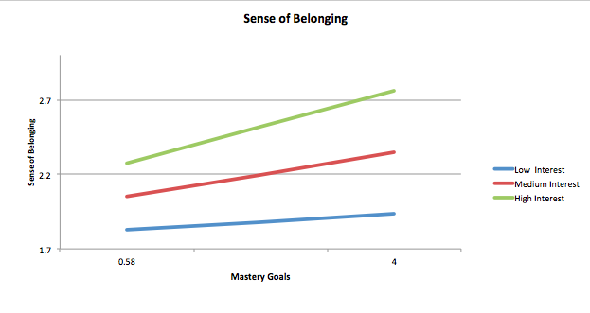

Using the Johnson-Neyman test revealed that within the low teacher interest scores (one standard deviation below the mean), the teacher interest variable was not predictive of sense of belonging, with b = .059, t(154) = .6260, p < .05. Within the medium teacher interest scores (the mean), the teacher interest variable was predictive of sense of belonging, with b = .166, t (77) = 2.0446, p < .05. Within the high teacher interest scores (one standard deviation above the mean), the teacher variable was also statistically significantly predictive of sense of belonging, b = .273, t (191) = 2.8323, p < .05. These results indicate that an increase value in mastery goals was significantly predictive of increases value in sense of belonging, and an increase in teacher interest level was significantly predictive of an increase value in sense of belonging. The statistically significant interaction between perceived mastery goals and perceived teacher interest indicated that this association between mastery goal and sense of belonging was stronger at higher levels of teacher interest. In other words, the graph clearly shows that students' sense of belonging increases with higher values of classroom mastery orientation. And, that the values of sense of belonging are further enhanced when teacher interest is at the higher levels.

The relationship between classroom mastery goal orientation and sense of belonging is enhanced by perceived teacher interest. Which means that at the higher levels of teacher interest, sense of belonging is stronger for students along all values of classroom mastery orientation. However, at the low level of teacher interest, it has no effect on the positive predictive strength of classroom orientation on sense of belonging. From this analysis we can conclude that student sense of belonging depends on the values of the classroom mastery; and that the values of sense of belonging is stronger when students also feel the teacher interest is higher. At the low teacher interest the enhancing effect is weaker (not statistically significant).